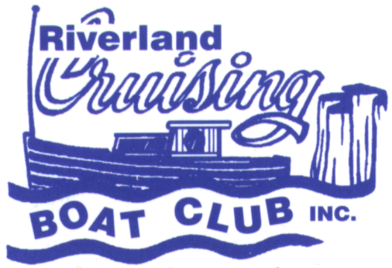
RIVERLAND CRUISING BOAT CLUB
P.O. BOX 1496,
RENMARK, SOUTH AUSTRALIA 5341

Email: secretary@riverlandcruisingboatclub.org.au

Website: www.riverlandcruisingboatclub.org.au

Facebook: https://www.facebook.com/groups/riverlandcruisingboatclub
ABN:46 457 392 781
BSB 105052 Account: 50489140

Lindner’s Landing Dinghy Dawdle 2026

Friday March 27 to Monday March 30 (inclusive)

Starting Point: Lindner’s Landing (655 Murtho Road, Paringa) – Campsite 2

Finishing Point: Lindner’s Landing

Note: the plan is to be based at Lindner’s eg camp on land or in boats for the entire weekend, then do dinghy dawdles each day, returning to camp each afternoon/evening. Participants may camp on land or on boats moored at the campsite. The daily itinerary will be decided closer to the time depending on river levels however the location allows for exploration of a range of creeks and waterways in close proximity to Lindner’s.

Number of Days: 4 (with the opportunity to add on an extra day before and/or after).

Notes regarding Boats: Although participants may wish to bring larger boats (eg houseboats, cruisers, trailer sailer’s) to moor at Lindner’s to sleep/camp on, the daily dawdles will be suitable for tinnys ONLY (ie those with the ability to get up on the plane). Participants may also wish to bring canoes for self-directed activities when time allows.

Any Other Initial Information:
- Cost: donation of $10/vehicle/night to the Lindner family (this event will be covered by RCBC).
- Gravel boat ramp available at Lindner’s (suitable for 4WD launching of tinnys ONLY ie not larger boats)
- Participants may cruise up from Renmark in larger boats to sleep on and moor at the campsite or camp on land. Shuttling of cars/people from Renmark to Linder’s can be arranged closer to the time.
- Dogs allowed under effective control
- Participants will need to self-cater, however a trip to the Woolshed Brewery may be included in the itinerary on the Sunday. (at participants own expense)
- There is plenty of room at Lindner’s to leave trailers and cars.
- There are a number of conditions specified by the Lindner family including no chainsaws (full list can be provided on request)
- Amenities trailer would possibly be on site for the event – TBC depending on availability of Club personnel to assist.

REGISTRATION FORM

EVENT ORGANISERS: If you have any questions, please contact:
Lissa Selga: 0438 867 863 Jill & Graham Rainbow: 0429 692 000

REGISTRATION FEE: $10.00 per car/boat per night will be covered by RCBC.
NAME: |  |  | PHONE:  (Mobile preferred)
POSTAL
ADDRESS:
EMAIL ADDRESS:
TYPE OF BOAT  (Please Tick) | HOUSEBOAT □ | HALF CABIN □ | TRAILER SAILER □ |  | CRUISER □
TYPE OF BOAT  (Please Tick)
  Tinny □ | Dinghy □ | Other (Please describe)
TYPE OF BOAT  (Please Tick) | Notes regarding Boats:  Although participants may wish to bring larger boats (eg houseboats, cruisers, trailer sailers) to moor at Lindner’s to sleep/camp on, the daily dawdles will be suitable for tinnys ONLY (ie those with the ability to get up on the plane). Participants may also wish to bring canoes for self-directed activities when time allows.
LENGTH OF BOAT |  | NAME OF BOAT
ADDITIONAL PASSENGERS  Name: |  | Phone: | Email:
FURBABIES – Name: |  | Breed/colour | Size: Small Medium Large

Riverland Cruising Boat Club (RCBC) – it is the responsibility of each boat owner to ensure their boat is insured and for boat owners to have 3rd party insurance.
If you are taking your pet on your boat or to the campsite – pets must be under effective control at all times and owners are required to clean up after their pets.

PLEASE RETURN TO THE SECRETARY: secretary@riverlandcruisingboatclub.org.au
by Saturday 28th February 2026
REGISTRATION FORM | INCLUDED  YES / NO | PLEASE ENSURE ALL SECTIONS ARE COMPLETED

